Tab 1

## Snapdocs

## Implementation POC: Jeff *(IM to fill)* CX POC: *[IMP to Add]*

### 

### 

| Notes Sections   *(AE to fill if they have, Implementation to be completion DRI on handoff)*   * Info on how merchant bills * Three revenue streams   + **Digital** - implementation fees, usage, consumption with overages   + **Scheduling/Signing** - SaaS fee   + First Class - We will not be handling this revenue stream, maybe one day   1) What is the merchant temperament?   * Paul Micheli- Sr. Accounting Manager in southern CT, gunning for controller promo mid-year. Talkative, great rapport, the biggest Tabs champion ever * Lissa (Melissa) Frease- accounting manager in colorado, a little quieter, very bright, more in the weeds than paul but will still follow paul’s lead * David Shin - Accounting associate in vegas, also a little quiet but super sweet. Was the only one hesitant at first with tabs and selling the roadmap but paul turned him around. * Jason anderson, head of finance in colorado, likely won’t come to calls but he was EB. Very bro-ey, very nice and also sharp. Loves tabs, really likes Ali   3) What are the Tabs features that the key POC cares about?   * Statements (roadmap) * Automated contract ingest - especially the accuracy * Manually change invoices * Rev Rec * Commitment tracking * Custom Reporting * Cash application and their team in the philippines having access |
| --- |

### Billing model *(Entire Section: Implementation to fill section)*

* Are there unique things about the customer creation process for this merchant?
* Information on how merchant bills
* How contract is broken up
* One off things to know about the merchant

### Contract Processing Steps *(Entire Section: Implementation/Success to fill Post-Go Live)*

### **General**

### Products will be in the Digital Closing Services & Fees and Implementation tables

### Digital Closing Services section (this will be all the BTs with a “(per closing)” price) will be Usage BTs

* + Implementation fees will be one-time, flat BTs
  + *If there are any of the below present* in the contract, we will need to turn on Usage AI:
    - Prepaid/anticipated usage amount for usage
    - Committed usage amount
    - Rollover credit
* **Event and Integration Mapping**
  + All events and integration items should be selected using this [Product Mapping Sheet](https://docs.google.com/spreadsheets/d/1-H63RP5Q44dYgsWyNL_JqgGNNdWeV6veIUwhvZbiVH4/edit?usp=sharing)
    - Column B is the event name
    - Column F (“QBO Map”) is the integration item
* **Item Name:**
  + listed in the “Service” column
  + If the same line item has multiple prices or different years and you need to split into separate BTs, use judgement to differentiate the names
    - 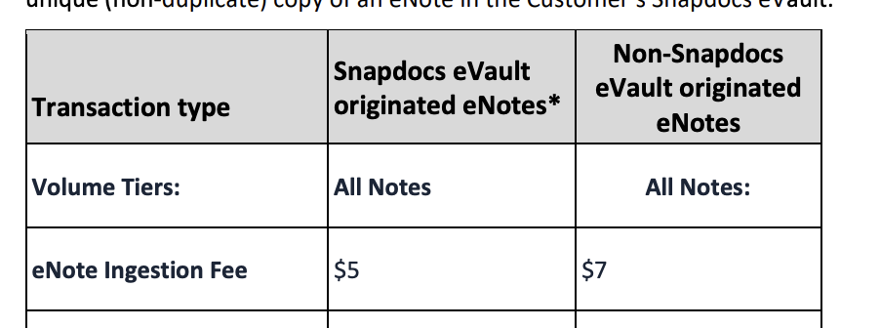
      * Would be Volume Tiers (Snapdocs Originated) and Volume Tiers (Non-Snapdocs Originated)
  + If multiple years, use “(Year 1)” and “(Year 2)” at the end of the name
* **Item Description:** Do NOT include any description
* **Price:**
  + listed in the “Fee Column”
  + If something like “Closing Fee + $10” is listed, just use the dollar amount
* **Frequency:**
  + For the usage products, look for language like the following: “Customer will be invoiced for usage monthly in arrears until the end of the service period.”
  + Most are monthly in arrears
  + One-time payments can be NONE
* **Billing Start Date / Service Start Date:**
  + Billing date and service start date should match
  + Mostly top left of order form after “Order Effective Date:”
    - Mostly either a listed date or “date of last signature”
  + If multiple prices or years for the same product (or both), use the date the product will be billed for (***ONLY do this if the contract explicitly breaks out different years)
    - Example: Hybrid Closing product
      * Year 1: $20 per closing
      * Year 2: $20 per closing
      * Year 3: $25 per closing
    - This should be 3 separate BTs (even though year 1 and 2 are the same price)
    - Each should have 12 months of service and should start on each respective year
      * So if contract start 1/1/2025, the year 2 BT should start 1/1/2026, etc.
* **Months of Service:**
  + Listed in “Order Term” in top right corner
  + Make sure to follow the logic above for different years / different prices for the same product (ONLY if the contract breaks out separate years)
  + If there is a specified end date, take the number of months between start and end (be sure to round up if not exact)
  + IF the contract term doesn’t go through today’s date at least, extend or duplicate the BTs so that it does
  + For Implementation / One-Time fees:
    - If it lists how long implementation is (“The estimated time to complete the Implementation Services is 60 days following commencement.”) - use this length
    - If not listed for implementation, assume 2 months
    - For other “one-time fees” that aren’t implementation, use 0
* **Net Terms:** listed in “Payment Terms” in top right corner
* **Prepaid / Anticipated Usage:**
  + Language will look something like this: “Customer will be invoiced for anticipated usage according to the table below”
  + Will need to turn Usage AI on and depending on how it is set up, follow a variation of the below instructions
  + [Example](https://garage.tabsplatform.com/prod/contracts/5ac52121-67d0-49bd-8c1b-82f720c37ed7/terms/revenue)

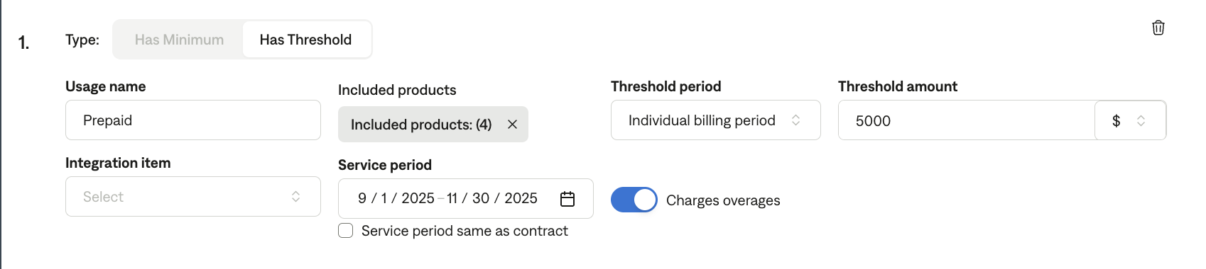

* + - Will need a Flat BT for the prepaid amounts
    - “Has Threshold” -> Included Products: select all usage products -> “Billing Period” for threshold period -> threshold amount is monthly prepaid amount -> “charges overages”
    - Can call it “Prepaid”
    - service period should cover the entire range that the prepaid amounts go for
      * For example, the example contract has the customer prepay usage for 3 months
      * Because the usage products go for 12 months, we have to input the 3 month date range in the service period since it is shorter
  + If you are unsure how to set up Usage AI for a unique model, please flag
  + Additional examples
    - 4 years with a prepaid amount and 4 years with different usage products ([LINK](https://garage.tabsplatform.com/prod/contracts/14b20a3b-e420-4b77-95ee-23154f6c81ba/preview))
      * Had to manually set the service period and select the appropriate products for that year
* **Rollover Credits**
  + Rollover credits are the same thing as the above prepaid instructions
  + First, determine at what frequency the credit is applied as for what
    - Could be no defined term [LINK](https://garage.tabsplatform.com/prod/contracts/928df4ff-b218-4e23-898d-6623d6c8ad6b/usage)
      * “will be applied toward any Fees due under this Order Form”
    - Or a monthly credit [LINK](https://garage.tabsplatform.com/prod/contracts/e4f4ec49-cc97-4391-be33-b359b9ccbd16/usage)
  + Use the same instructions as above but select full service term for threshold period if not limit to credit and select individual billing period if monthly
  + Select the appropriate products
* **Amendments**
  + Make sure the amendment BTs match up with the original contract invoices and end at the same time as the original contract
  + Amendments often won’t have end dates because the end date is the original contract end date
  + Example
    - Original contract is 1/5/2025 - 1/4/2026
    - Amendment is 6/17/2025
      * Amendment BTs should be monthly in arrears starting on 6/5/2025 (to line up with the original invoices) and have the same net terms
      * Will end on 1/4/26 as well
* **Closing Commitments**
  + Ignore for now
* **Additional Item Mapping:**
  + For the item “Closing Quality Control (CQC) Add-on”
    - Event and integration item should be “Funding Quality Control”
* **Additional examples**
  + [Bell Bank](https://garage.tabsplatform.com/prod/contracts/36cc5c26-a375-4fd5-ac0a-338ad3335b1a/terms/revenue)
  + [2 Different Annual Commit Years](https://garage.tabsplatform.com/prod/contracts/2ca5d4e4-751c-43a3-9df2-2efe2c8334cc/usage)
  + [Early access period amendment](https://garage.tabsplatform.com/prod/contracts/17faff16-4f06-43db-8bf9-cc00417092c6/terms/revenue)
  + [Usage products cover different years](https://garage.tabsplatform.com/prod/contracts/e5f07b3f-effa-4713-a72b-15c830ed544e/terms/revenue)

### Events Processing (if necessary) *(Entire Section: Implementation/Success to fill Post-Go Live)*

* Any important information on events billing

Integration Items Processing (if necessary)  
*(Entire Section: Implementation/Success to fill Post-Go Live)*

* What are the instructions for assigning integration items?
* Example: All Statsig integrations items should be labeled as “Sales”
* Example: All “Pinata” integration items should be labeled as “Software Subscription Bundle” unless otherwise noted by Merchant

Post Processing Communications (if necessary)  
*(Entire Section: Implementation/Success to fill Post-Go Live)*

* Does the Ops Team need to notify anyone on the team re: completion of processing batches in Implementation or Active phase?
* Who needs to be notified and when?
  + Example:
    - Who: Customer Success [Azmat Aziz] needs to be notified
    - Where: Messari internal merchant channel
    - When: contracts are processed [Merchant Phase: Active]

### Customer Information *(Entire Section: Implementation/Success to fill Post-Go Live)*

* Any important information on specifics customers of this merchant
  + Special memo’s certain invoices require
  + Invoice changes due to merchant/customer relationship

### Feature Requests *(AE to fill for all requests prior to Imp handoff, Imp to fill prior to go-live/Success to fill to fill Post-Go Live)*

* Statements
  + Sending a “statement” with all unpaid (including partially paid) invoices and breaking out every billing term that used to be on one invoice into its own invoice on a statement so we can apply cash on billing term (now invoice) level
  + Lenders get invoiced 10 BTs, each BT is payed to the lender separately through a month+. The lender sends each payment to Snapdocs and Snapdocs needs to apply payment on a BT basis. We are now turning BTs into their own invoices and making it easier to view for Snapdocs’ customers but putting them all on one statement.
  + [Here is a snippet of what I proposed and the team’s reactions/questions](https://us-56595.app.gong.io/call?id=9080504313501906472&highlights=%5B%7B%22type%22%3A%22SHARE%22%2C%22from%22%3A114%2C%22to%22%3A750%7D%5D)
  + Urgency - by go live, if not sooner

### Merchant Calls *(AE to fill for all videos prior to Imp involvement, Imp to fill prior to go-live/Success to fill to fill Post-Go Live)*

* Loom recording links by dates